ANALYZING THE FACTORS THAT AFFECT LIFE EXPECTANCY
(EXAMINING WORLD HEALTH ORGANIZATION LIFE EXPECTANCY DATASET)

Presented
By:
ADEDOKUN ENIOLA

Submitted to:
Femtech Information Technology Institute
158 Ibrahim Taiwo Road, Ilorin, Kwara State, Nigeria.

In Partial Fulfilment for The Award of Diploma in Data Analysis

Supervised by:
Mr. Joseph

April, 2025

CERTIFICATION
This is to certify that this project, titled ANALYZING THE FACTORS THAT AFFECT LIFE EXPECTANCY was carried out by ADEDOKUN ENIOLA, has been read and approved as meeting the requirement for the Award of Diploma in Data Analysis using Power BI.
Project Coordinator  Mr. Ayo Samuel | Date
Supervisor  Mr. Joseph | Date
Institute Admin
Miss Elizabeth Aderibigbe
Student  Adedokun Eniola | Date

DEDICATION
I dedicate this work to God, the sustainer of my life, for His grace, strength, and unwavering presence throughout this journey. I am also deeply grateful to my family and friends whose steadfast support, encouragement, and belief in my abilities have been my guiding light every step of the way.

ACKNOWLEDGEMENT
My heartfelt appreciation goes to the sponsor of this scholarship, Seeding Africa, for their generous financial support, invaluable guidance, and inspiring mentoring sessions that played a significant role in making this achievement possible.
I wish to express my sincere thanks to all my instructors for their patience, constructive feedback, and continued support, which greatly contributed to shaping the direction and quality of this project.
I am equally thankful to my peers and colleagues who offered helpful suggestions, shared ideas, and fostered a collaborative and enriching learning environment.
To everyone who contributed directly or indirectly to the success of this work — thank you.

ABSTRACT
This project focuses on analyzing the factors that affect life expectancy, with particular attention to variables such as immunization rates, GDP, social factors, and mortality rates. The study leverages the World Health Organization (WHO) Life Expectancy Dataset, utilizing tools such as Power Query and Power BI to derive meaningful insights and identify key predictive factors contributing to lower life expectancy values.
Key steps in the project include data acquisition from Kaggle, followed by data cleaning, transformation, visualization, and analytical interpretation. The analysis reveals significant trends and patterns that highlight how specific socioeconomic and health-related factors influence life expectancy. These insights can assist policymakers in identifying and prioritizing critical areas for intervention to effectively enhance a nation's average life expectancy.
This work contributes to a broader understanding of global health metrics and serves as a foundational step for future research and deeper analysis in related domains.

TABLE OF CONTENTS
TITLE PAGE……………………………………………………………………………………………………………………………………………….i
CERTIFICATION ii
DEDICATION iii
ACKNOWLEDGEMENT iv
ABSTRACT v
CHAPTER ONE 1
INTRODUCTION 1
1.1 BACKGROUND OF STUDY 1
1.2 DEFINITION OF TERMS (FREQUENT WORDS) 1
1.3 STATEMENT OF THE PROBLEM 2
1.4 AIM AND OBJECTIVES 3
1.5 SIGNIFICANCE OF THE STUDY 3
CHAPTER TWO 4
LITERATURE REVIEW 4
2.1 REVIEW OF PREVIOUS PROJECT 4
CHAPTER THREE 6
METHODOLOGY 6
3.1 DATA SOURCES AND DESCRIPTION 6
3.2 TOOLS USED AND JUSTIFICATION 8
3.2 PROCESS INVOLVED IN THE STUDY 8
CHAPTER FOUR 10
RESULTS AND DISCUSSION 10
4.1 DATA PRESENTATION AND DISCUSSION OF FINDINGS 10
4.2 RECOMMENDATION FOR STAKEHOLDERS 14
CHAPTER FIVE 16
CONCLUSION 16
5.1 SUMMARY OF FINDINGS 16
5.2 CONCLUSION 16
5.3 PROJECT LIMITATIONS 17
5.4 RECOMMENDATIONS FOR FUTURE RESEARCH 17
REFERENCES 19

CHAPTER ONE

INTRODUCTION

1.1 BACKGROUND OF STUDY
This project investigates the key factors that influence life expectancy across 193 countries over a 15-year period, from year 2000 to 2015. The dataset used consists of Two Thousand Nine Hundred and Thirty-Eight (2,938) rows and Twenty-Two (22) columns, encompassing a range of health, economic, and social indicators.
By leveraging data analytics tools, this study aims to identify key drivers of life expectancy, including immunization rates, GDP, mortality rates, and other health-related variables. With the growing global concern for enhancing population health and longevity, this analysis offers timely and valuable insights that can support informed decision-making and policy formulation.

1.2 DEFINITION OF TERMS (FREQUENT WORDS)
- Life Expectancy: The average number of years a person is expected to live based on current health conditions, socioeconomic factors and mortality rates.
- GDP: Gross Domestic Product per capita – a measure of a country's economic performance.
- Immunization Rate: The percentage of the population that has received vaccinations against common diseases.
- Mortality Rate: The frequency of deaths in a population, often categorized by age group or cause.
- Dataset: A structured collection of data, often presented in tabular form, consisting of rows and columns.
- Regression Analysis: A statistical method used to assess the relationship between variables, often to predict one variable based on others.
- Correlation Tests: Statistical techniques that measure the strength and direction of relationships between two or more variables.
- Econometric Models: Models that apply statistical methods to economic data to test theories or predict future trends.
- Data Storytelling: The use of data visualizations and narrative techniques to present data in an engaging and understandable way.

1.3 STATEMENT OF THE PROBLEM
Despite advancements in medicine and technology, many countries face stagnating or declining life expectancy due to factors like inadequate healthcare, economic inequality, poor immunization, and high mortality rates. A major challenge for policymakers is the lack of accessible, data-driven insights to identify the most impactful factors. This project aims to address this by analyzing health and socioeconomic data from 193 countries, using Power Query and Power BI to uncover trends and present actionable insights for evidence-based decision-making to improve population longevity.

1.4 AIM AND OBJECTIVES
AIM:
Analyze key factors influencing life expectancy across countries using data analytics to support public health strategies and policy-making.
OBJECTIVES:
- Clean and prepare the dataset with Power Query for accuracy and readiness.
- Analyze the impact of variables like immunization, GDP, social factors, and mortality on life expectancy.
- Visualize trends and insights using Power BI through interactive dashboards.
- Identify the most influential predictors of low life expectancy.
- Support data-driven decisions to improve health outcomes for policymakers and stakeholders.

1.5 SIGNIFICANCE OF THE STUDY
This study analyzes life expectancy determinants across 193 countries, highlighting the impact of immunization, GDP, socioeconomic factors, and mortality rates. The findings offer valuable insights for governments and policymakers to optimize resources. Using Power Query and Power BI, the study demonstrates how data visualization transforms complex datasets into actionable insights, supporting decision-making for non-technical stakeholders. Ultimately, it contributes to improving global health outcomes and reducing life expectancy disparities through data-driven strategies.

CHAPTER TWO

LITERATURE REVIEW

2.1 REVIEW OF PREVIOUS PROJECT
Several studies have examined life expectancy in relation to factors such as economic development, healthcare quality, education, and environmental influences. These studies have provided valuable insights into the determinants of life expectancy, often utilizing statistical methods such as regression analysis, correlation tests, and econometric models. However, much of the existing research tends to focus on presenting numerical findings without offering a clear, visual narrative that can be easily interpreted by a broad audience.
While statistical approaches are important, fewer projects have incorporated modern data visualization tools to present findings in a dynamic and accessible way. The use of visual tools like Power BI allows for the transformation of complex datasets into interactive, intuitive dashboards, enabling stakeholders to explore data in real time. These visualizations not only highlight key trends and patterns but also facilitate deeper engagement and understanding among policymakers, researchers, and the general public.
Moreover, traditional studies often lack integration with user-friendly platforms, making it difficult for non-technical users to extract practical insights from large datasets. This gap limits the application of such research in real-world policy development and public health interventions.
This project builds on prior work by leveraging advanced data visualization techniques, offering a more interactive and engaging approach to understanding life expectancy data. By incorporating data storytelling, this study enhances the ability to communicate the relationships between health, economic, and social factors in a compelling manner. The use of Power Query for efficient data transformation and Power BI for dynamic dashboards distinguishes this work from conventional research approaches.
Ultimately, the project aims to make life expectancy data more accessible, actionable, and impactful. It bridges the gap between complex analysis and practical application, supporting evidence-based decision-making that can lead to meaningful improvements in global health outcomes.

CHAPTER THREE

METHODOLOGY

3.1 DATA SOURCES AND DESCRIPTION
The primary dataset, "WHO Life Expectancy Data," was sourced from Kaggle and compiles statistics from the World Health Organization (WHO), United Nations, and other international organizations.
DATASET OVERVIEW:
- Rows: 2,938
- Columns: 22
- Countries Covered: 193
- Years Covered: 2000 to 2015
DEFINITION OF TERMS (DATASET VARIABLES)
The dataset includes a variety of health, economic, and social indicators, such as:
- Country: The name of the nation represented in each record.
- Year: The year the data was recorded.
- Status: Classification of the country as either Developed or Developing.
- Life expectancy: The average number of years a person is expected to live at birth.
- Adult Mortality: The probability of dying between the ages of 15 and 60 per 1,000 population.
- Infant Deaths: Number of deaths of infants under one year old per 1,000 live births.
- Alcohol: Average alcohol consumption per adult (age 15+) in liters per year.
- Percentage Expenditure: Expenditure on health as a percentage of GDP per capita.
- Hepatitis B: Percentage of 1-year-old children immunized against Hepatitis B.
- Measles: Number of reported measles cases per 1,000 population.
- BMI: Average Body Mass Index of the population (age-standardized).
- Under-five Deaths: Deaths of children under five years per 1,000 live births.
- Polio: Percentage of 1-year-old children immunized against Polio.
- Total Expenditure: Total government health expenditure as a percentage of total government expenditure.
- Diphtheria: Percentage of 1-year-old children immunized against DPT (Diphtheria, Pertussis, and Tetanus).
- HIV/AIDS: Deaths per 1,000 population due to HIV/AIDS.
- GDP: Gross Domestic Product per capita (in USD).
- Population: Total population of the country.
- Income Composition of Resources: Index combining income, education, and life expectancy (a Human Development Index component).
- Schooling: Average number of years of schooling received by people ages 25 and older.

3.2 TOOLS USED AND JUSTIFICATION
- Power Query: Efficient data cleaning and transformation, simplifying large dataset handling.
- Power BI: Advanced visualization and interactive reporting with DAX measures for deep analysis.
- Kaggle: Provided the WHO Life Expectancy dataset, offering comprehensive global health data for analyzing life expectancy factors.

3.2 PROCESS INVOLVED IN THE STUDY
The workflow involved the following stages:
- Data Collection: Sourced from Kaggle (WHO Life Expectancy Dataset)
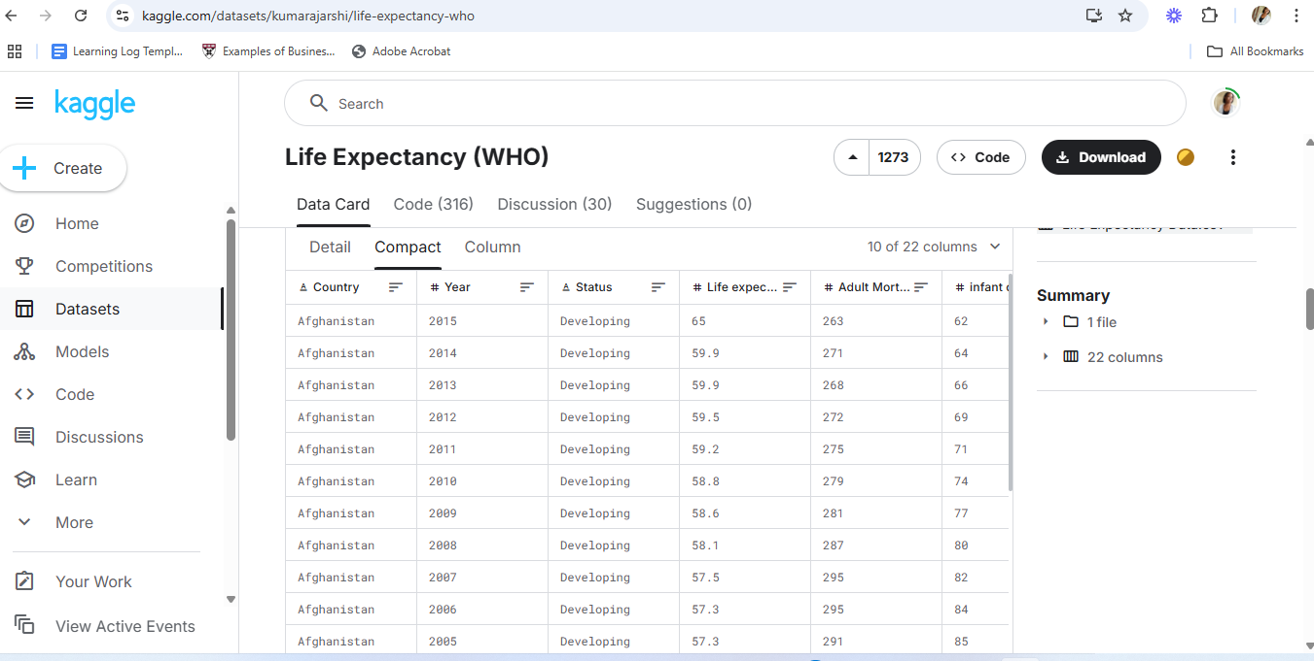
  - Data Cleaning: Removing missing values, standardizing formats in Power Query
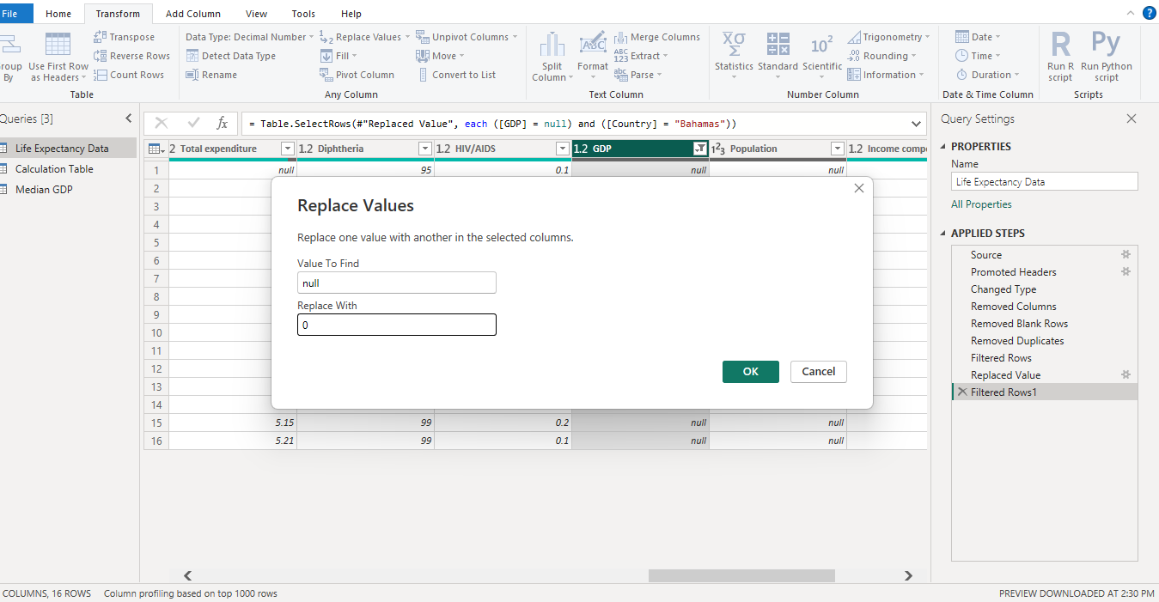
  - Transformation: Creating new calculated columns, add column from example
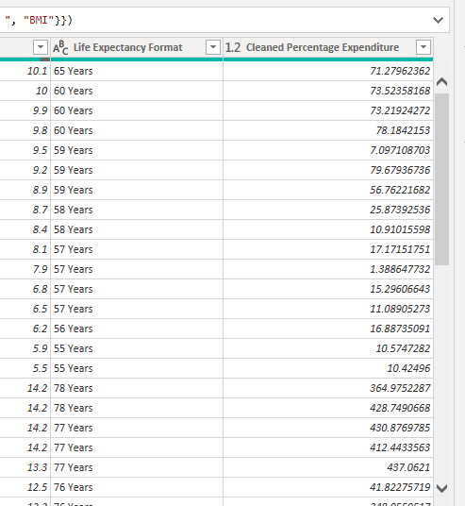

  - DAX (Data Analysis Expressions) Measure: used to create calculation tables and measures that allow for advanced analysis.
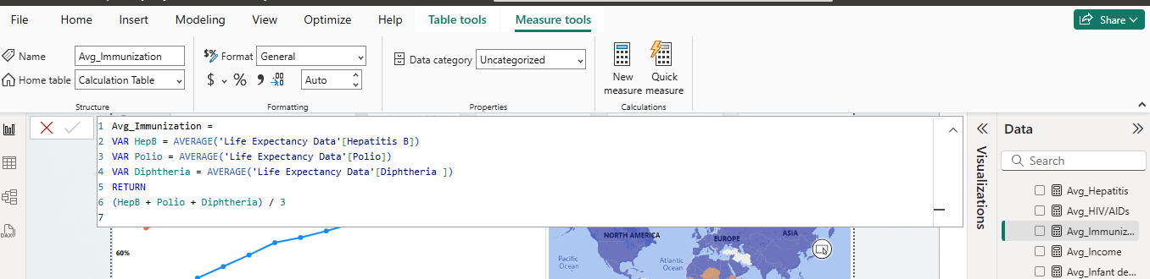

CHAPTER FOUR

RESULTS AND DISCUSSION

4.1 DATA PRESENTATION AND DISCUSSION OF FINDINGS
This chapter presents the analyzed data using visualizations created in Power BI and discusses the key insights derived from the WHO Life Expectancy dataset. The analysis covers 193 countries over the period of 2000 to 2015, with emphasis on the relationships between life expectancy and various health, economic, and social factors.
  - Impact of Immunization Rates:
The analysis includes a line chart showing life expectancy trends alongside immunization efforts, a global map visualizing regional immunization rates, a bar chart comparing immunization coverage by country, and a table with immunization percentages for all countries.
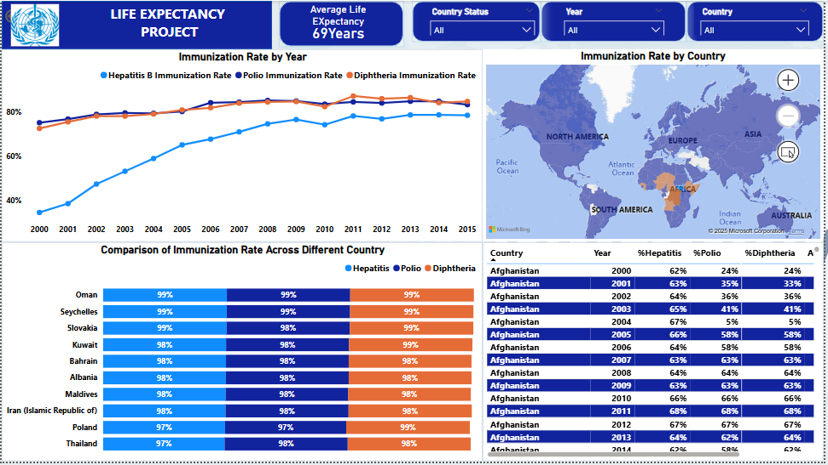
  - Analyzing GDP:
A line chart shows the GDP trend in relation to life expectancy, a bar chart compares GDP and life expectancy across countries, and a scatter plot visualizes the relationship between health spending and life expectancy.
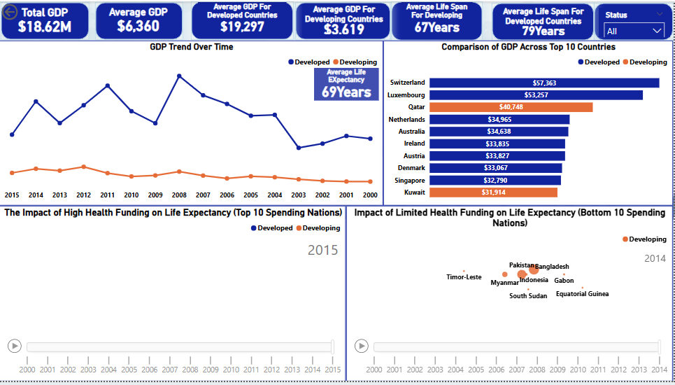
  - Analyzing Social Factors:
A line chart shows the trend of social indicators (education, income, alcohol) in relation to life expectancy. A column chart compares education levels and life expectancy, while a chart highlights income composition and its correlation with longevity. The impact of alcohol consumption is visualized, and a combined chart presents the overall influence of all social factors on life expectancy.

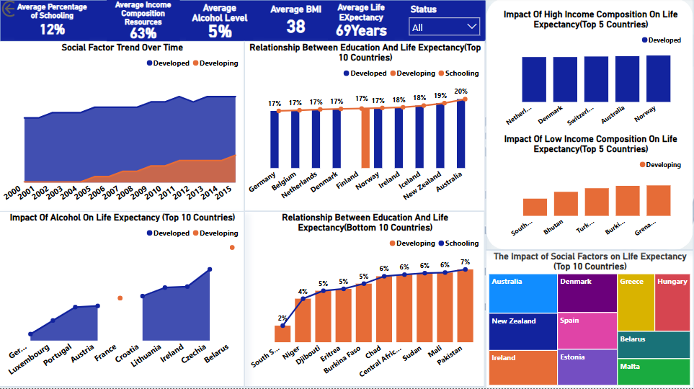
  - Impact of Mortality Rates:
A line chart shows trends in mortality rates (adult and infant) and measles cases over time, linking them to life expectancy. Column charts compare countries with high measles cases and infant mortality, highlighting geographic disparities. A bar chart contrasts countries with high and low mortality rates in relation to life expectancy. 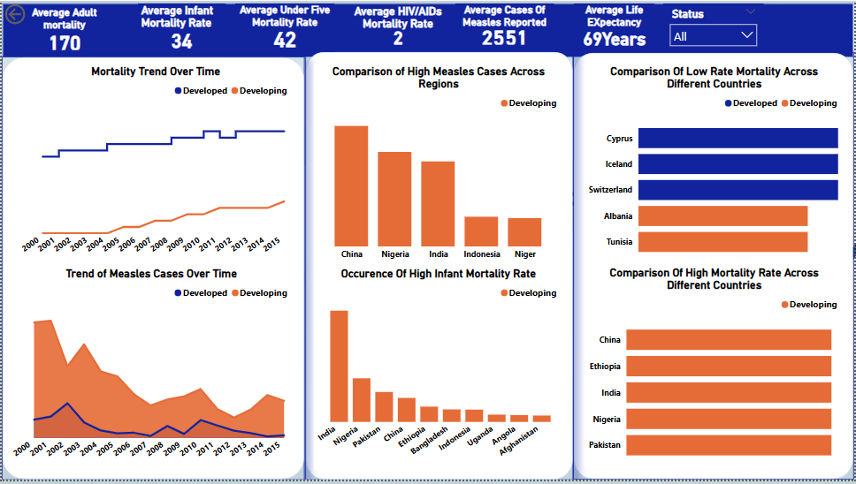

DISCUSSION OF FINDINGS
The analysis of the WHO Life Expectancy dataset revealed several critical insights into the health and socio-economic factors influencing life expectancy across 193 countries from 2000 to 2015:
- Immunization Rate:
Countries with higher immunization coverage consistently showed higher life expectancy. Nations with strong vaccination programs, especially for diseases like hepatitis B, polio and diphtheria, experienced lower mortality rates and longer average lifespans.
- GDP and Health Spending:
A positive relationship was observed between GDP per capita and life expectancy. Countries that allocated a greater percentage of their GDP to health spending tended to have better health outcomes and longer life expectancy. However, some countries spend a higher percentage on health, but the per capita expenditure ends up being disproportionately high, which may negatively impact life expectancy.
- Social Factors (Education, Income, Alcohol Use):
Higher education levels and better income composition were strongly associated with increased life expectancy. Interestingly, countries with higher alcohol consumption also reported relatively higher life expectancy, indicating that alcohol intake may not always have a direct negative impact on longevity.
- Mortality Rates:
A decline in adult and infant mortality over the years positively impacted life expectancy. Countries with persistently high mortality rates tended to report lower average lifespans.
- Regional Trends and Disparities:
Developed countries generally had higher life expectancy due to stronger healthcare systems and better social support. In contrast, many developing nations showed lower life expectancy due to limited access to healthcare, education, and economic opportunities.
- Data Visualization Impact:
The use of Power BI dashboards made it easier to uncover hidden patterns and communicate insights effectively to non-technical stakeholders, aiding data-driven decision-making.

4.2 RECOMMENDATION FOR STAKEHOLDERS
- Invest in Immunization: Increase funding and accessibility for vaccination programs, particularly in regions with high mortality rates.
- Enhance Health Spending: Allocate resources efficiently to improve healthcare infrastructure and access.
- Promote Education: Support public health education, especially in areas with low literacy and high disease rates.
- Address Socioeconomic Disparities: Implement policies to reduce income inequality and unemployment, improving access to healthcare.
- Monitor Alcohol Consumption: Launch campaigns to reduce excessive alcohol use, which negatively impacts life expectancy.
- Strengthen Data-Driven Decisions: Use business intelligence tools like Power BI for real-time health monitoring and planning.
- Foster Global Collaboration: Support international partnerships to share resources and improve global health outcomes.

CHAPTER FIVE

CONCLUSION

5.1 SUMMARY OF FINDINGS
This project analyzed life expectancy data from 193 countries between 2000 and 2015 using Power Query and Power BI. Key findings include:
- Immunization and Life Expectancy: High immunization coverage correlates with lower mortality and longer life expectancy.
- GDP and Health Spending: Higher GDP and health investments lead to better health outcomes and longer lives.
- Social Factors: Education and income positively impact life expectancy, while high alcohol consumption reduces it.
- Mortality Rates: High infant and adult mortality rates lower life expectancy, particularly in low-income countries.
- Regional Disparities: Developed countries outperform developing nations in health, highlighting global healthcare inequality.

5.2 CONCLUSION
This project has successfully demonstrated how data analytics can uncover meaningful insights into the factors affecting life expectancy across the globe. By leveraging the WHO Life Expectancy dataset and using tools like Power Query and Power BI, the analysis highlighted the significant impact of immunization, GDP, social factors, and mortality rates on population longevity.
The study confirmed that increased investment in healthcare, education, and income equality positively correlates with improved life expectancy. It also revealed regional disparities, emphasizing the need for targeted policy interventions in underperforming areas.
Through interactive dashboards and visual storytelling, this project made complex data accessible and actionable. These insights can serve as a powerful resource for policymakers, health organizations, and researchers committed to improving global health outcomes.
Ultimately, this analysis lays a foundation for future research, with potential for deeper exploration using machine learning and predictive models to further enhance decision-making in global health.

5.3 PROJECT LIMITATIONS
- Some data entries were missing or inconsistent, affecting the completeness and accuracy of the analysis.
- The dataset was limited to data available up to a certain year, which may not reflect current health and socioeconomic conditions.
- Lack of region-specific variables such as cultural practices, dietary habits, and lifestyle factors that could also influence life expectancy.
- The dataset did not capture healthcare quality or infrastructure, which are critical components of public health outcomes.
- Certain indicators, like education or income, were broad and may not reflect disparities within countries or specific populations.
- External factors such as political instability, pandemics, or climate change were not accounted for, despite their potential impact on life expectancy.
- The analysis relied heavily on correlations and did not establish causal relationships between variables.
- Some countries had incomplete records for specific years, which limited the ability to conduct uniform year-on-year comparisons.

5.4 RECOMMENDATIONS FOR FUTURE RESEARCH
- Expand the dataset to include more recent years and additional variables such as education levels, healthcare access, and environmental factors.
- Apply predictive analytics to model and forecast future trends in life expectancy across regions.
- Customize dashboards for specific regions, income groups, or target demographics to enhance targeted analysis and policy relevance.
- Integrate machine learning techniques to improve the accuracy of identifying and ranking the most influential factors affecting life expectancy.
- Explore causal relationships beyond correlations to better understand the direct impact of specific health and social indicators.

REFERENCES
Kaggle. (2020). Life Expectancy (WHO) Dataset. Retrieved from https://www.kaggle.com/datasets/kumarajarshi/life-expectancy-who
OECD. (2023). Health at a Glance: Indicators on Health Spending and Life Expectancy. Retrieved from https://www.oecd.org/health/
UNICEF. (2022). Immunization and Child Health. Retrieved from https://www.unicef.org/immunization
World Health Organization (WHO). (2024). Life Expectancy Data. Retrieved from https://www.who.int

